
EIFL-FOSS: Free and Open Source programme
Improving ICT infrastructure in libraries

J-ISIS Armenia: Providing online access for archives
(jANUARY 2011 – OCTOBER 2011)
EIFL-FOSS Pilot Project Report
Full case study
January 2012

J-ISIS (or Java ISIS) is a general purpose Open Source database system entirely written in Java and based on existing and solid FOSS software packages, such as Berkley DB and Lucene, from the Apache Foundation.

This case study was compiled by Tigran Zargaryan, National Library of Armenia, in November 2011 and edited by EIFL-FOSS.

Summary

Problem
In Armenia, many information repositories have some computing technology and internet connectivity, but they do not yet have the capability for putting their archives online in a format compatible with others. Additionally, they face the challenge that many Armenian archives began digitising between the mid 1980s and 1990s using WinISIS system; since this system pre-dates the internet, it is not web based and is not UNICODE compatible.

Project
Selected during the EIFL-FOSS call for pilot projects, the project’s goal was to pilot J-ISIS as a tool that could allow archives and resource centres to directly replace their existing WinISIS systems with a J-ISIS one that would allow internet access and UNICODE compatibility. During this pilot project, J-ISIS will be tested and recommendations will be produced on the suitability and potential for using this system in archives across Armenia.

Achievements
- J-ISIS was installed and learned that it is only fully UNICODE compatible for Latin-based scripts, and is still not handling others – including Armenian – correctly. The developers are actively working to resolve this issue (January 2012)
- Staff from the National Archives and Fundamental Scientific Library are ready to implement J-ISIS when the above mentioned minor problems will be resolved.
- The J-ISIS system will be included in the curricula of the ‘Library and Information Science’ school at the National Academy of Sciences.

Introduction
Following the EIFL-FOSS Call for Pilot Projects in October / November 2010, the Fundamental Scientific Library (FSL) of the National Academy of Sciences of Armenia demonstrated interest in piloting the J-ISIS product and to conduct a study of the advantages and disadvantages of the system for further use in archives and records management. For libraries, well structured and internationally approved standards are developed for automation and data exchange, but for archives such standards are not readily available, and each archive in Armenia has to solve the problem of automation on its own. This project was designed to move forward the automation agenda in Armenia.
The project was intended to discover whether such a technological upgrade would provide broader public access to the unique archival collections of the National Archives and Fundamental Scientific Library. Successful piloting of J-ISIS would allow archives and resource centres to directly replace their existing WinISIS systems with a J-ISIS one that would allow internet access and UNICODE compatibility. During this pilot project, J-ISIS would be tested and recommendations produced on its suitability and potential for use in archives across Armenia.
This project was led by Tigran Zargaryan, who moved during the course of the project from being the Director of the Fundamental Scientific Library to being the Director of the National Library of Armenia. He has been actively involved in the automation of libraries and archives for over 15 years, and has been instrumental in bringing the members of the CDS/ISIS family of software products to Armenian libraries and archives.

Project Background
Starting in 2002, with a grant from the Eurasia Foundation, automation activities started in Armenian archives, with the aim of starting digitisation activities using common templates and standards developed by archivists. The WinISIS system from UNESCO was chosen for automation, and after a series of training sessions the National Archives and the Fundamental Scientific Library started the automation of archival documents. However, the design of the WinISIS system dates back to the 1990s, and it is therefore not UNICODE compatible.
The ISIS software family includes many well-known elements, past and present, which are being used to develop various digital library modules:
- Micro CDS/ISIS (an advanced non-numerical information storage and retrieval software, MS-DOS platform and developed by UNESCO since 1985),
- WinISIS (the development of the Windows version of the CDS/ISIS system),
- Javaisis (a multilingual TCP/IP client/server suite, which allows access to a CDS/ISIS databases on any machine attached to the internet),
- WebLIS (web based library integrated system based on CDS/ISIS),
- ABCD (open source web based integrated library management software with modules for: cataloguing of books and serials; OPAC; circulation; acquisitions; statistics),
- J-ISIS (multiplatform open source ISIS client/server UNICODE based suite, that provides the same successful concepts and functionalities as the UNESCO ISIS family products).
Of all these products only ABCD and J-ISIS are FOSS products, and only J-ISIS has full UNICODE support. UNICODE compatibility is a vital consideration for any software under consideration – it is the only way of ensuring the software will operate successfully in the Armenian language.

About J-ISIS software
The intent behind the creation of the J-ISIS software is to develop a new multiplatform FOSS ISIS suite that would provide the same concepts and functionalities as the UNESCO ISIS suite while removing some of the disadvantages. The new software would be Client/Server, UNICODE, and would benefit from the latest software developments. The main objective of the software development is to provide the users with a long-term solution that would be modular, easy maintainable and extensible.
The ISIS family of software tools (CDS/ISIS, WinISIS, ABCD, J-ISIS) allow resource managers to create and change the database structure, display formats, and indexing strategies without having any knowledge of programming languages. Such an approach minimises the resource centre manager’s interaction with (and dependence upon) the software developers, and delivers a wide variety of techniques for the manager during database construction, and maintenance. Most importantly, ABCD and J-ISIS are FOSS tools and therefore help to preserve the limited budgets of the organisations, and therefore provide a key element in the sustainability strategy of the organisation.

Implementation of the J-ISIS FOSS Pilot Project
The project's initial plan was to test the J-ISIS main modules:
- Field Definition Table;
- Data Entry Worksheet;
- Print Format Table;
- Field Selection Table;
on supporting Armenian and Cyrillic (e.g. Russian) scripts. Cyrillic is in the range of a UTF-8 coding page, and Armenian is in the range of a full UNICODE coding page. Piloting of a system for both scripts would demonstrate how J-ISIS works with non-Latin alphabets, and how the indexing of content functions with them.
Piloting took place for two different releases: 'Web J-ISIS Beta' (9 December 2010), and later 'J-ISIS intermediate release' (27 October 2011) which has a Digital Library Data entry module and stopwords processing functionality.
All four of the modules listed above were thoroughly tested on handling with Armenian and Cyrillic scripts, on displaying Armenian and Cyrillic scripts, and on retrieval of data with Armenian and Cyrillic scripts.
All findings and problems were reported to the developers for further corrections.

Challenges
The main problem which we identified during the piloting is that J-ISIS still in fact needs improvements to become a system with full UNICODE support in all scripts. For example, when working with the ‘Print Format Table’, it was discovered that this format is not supporting Armenian (see Figure 1). Cyrillic support is provided successfully.

Figure 1. Screen capture of J-ISIS 'Print Format Table' showing the failure to correctly handle Armenian script.
The second major finding is that in the ‘Digital Library Data Entry’ mode the system can’t display Armenian and Cyrillic scripts in a proper UNICODE format (see Figure 2).
Figure 2: Screen capture of J-ISIS ‘Digital Library Data Entry’ mode showing that the system can’t display Armenian and Cyrillic scripts in a proper UNICODE format.
The third major problem occurs when exporting the records in the ISO2709 format. Encoding is being changed to other schema.
All of these major issues are reported to the developers, and we are in close contact with them to pilot new versions and solve the UNICODE problem.

Conclusions and Impact
- The J-ISIS system is not yet supporting full UNICODE for non-Latin scripts, although the developers are currently working to overcome this lack of functionality.
- Data indexing, information retrieval and display are now provided in a correct way (see Figures 3 and 4).
- J-ISIS will be a very good solution for building Digital Library modules from scratch when this issue is resolved.
- Staff from the National Archives and Fundamental Scientific Library are ready to implement J-ISIS when the above mentioned minor problems will be resolved.
- The J-ISIS system will be included in the curricula of the ‘Library and Information Science’ school at the National Academy of Sciences.
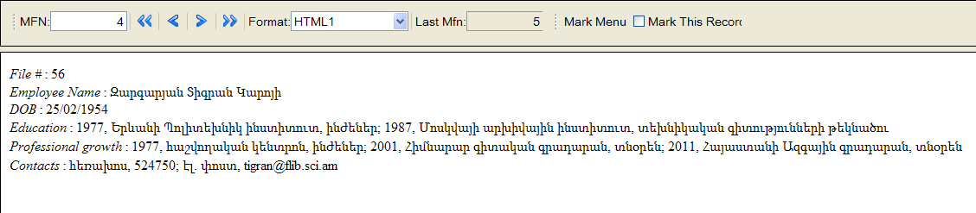
Figure 3. J-ISIS record in Armenian
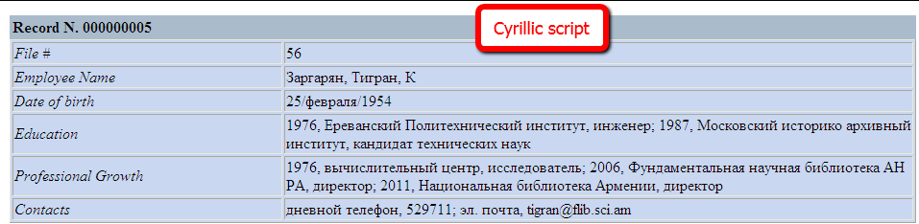
Figure 4. J-ISIS record in Russian

Further information about J-ISIS
- Languages: Any.
- Homepage: http://kenai.com/projects/j-isis
- Download page: http://kenai.com/projects/j-isis/downloads
- Licence: GNU General Public License (GPL)
- User community:http://kenai.com/projects/j-isis/forums/forum
- Developer community: http://kenai.com/projects/j-isis
- Learn more: see workshop presentation materials from our 2011 Regional Training Seminar (look for ILS Training Session 2)

Computerised Data Set/Integrated Set of Information Systems
http://kenai.com/projects/j-isis

